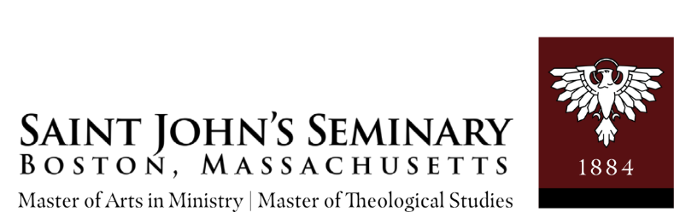

Promise for Tomorrow Scholarship
INITIAL Application Form

Personal Data

Legal Name:
 |  | (Last name) |  |  | (First name) |  | (M.I.) |  | (Title: Mr., Ms., |  | (Order)
 |  |  |  |  |  |  |  |  | Mrs., Sr., Br.)

E-mail:

Address:
 | (Street and Apartment/Unit#) |  | (City/Town) |  | (State) |  | (Zip Code)

Home Phone: ( |  | ) |  | - |  |  | Emergency Phone: ( |  | ) |  | -

Parish Affiliation:
 | (Parish) |  | (City/Town) |  | (State) |  | (Zip Code)

Degree Program: _____ Master of Arts in Ministry

_____ Master of Theological Studies for the New Evangelization

Summer 2023 I plan to take ____ course(s) for ____ credits. List course(s):______________________________________________________________________

Fall 2023 I plan to take ____ course(s) for ____ credits. List course(s):______________________________________________________________________

M.A.M. Formation ($800 per semester) _______

M.A.M. Field Education ($1,000 per semester) _______

M.T.S. Formation/Colloquium ($800 per semester) _______

Spring 2024 I plan to take ____ course(s) for ____ credits. List course(s):______________________________________________________________________

M.A.M. Formation ($800 per semester) _______

M.A.M. Field Education ($1,000 per semester) _______

M.T.S. Formation/Colloquium ($800 per semester) _______

(Please check all that apply):

Need-based_____

Merit-based_____

Catholic School Teacher_____

Many parishes offer financial support to students pursuing the M.A.M. or M.T.S. Degrees.

Have you asked your parish if they might be interested in paying for part of your tuition?

Please itemize the other definitive sources of financial support you will be receiving for the upcoming semester/school year, other than PFT Scholarship. Please place a -0- where no support is offered.
Family: ___________________ Work Study: _________ Parish: ___________________________________ Loans: _____________
Other institutions: _________________________ Other: ______________
Catholic Teacher scholarship: _____________
Please provide comments on any extenuating circumstances (e.g., are you retired, are you paying tuition for a dependent or adult child, are you recently unemployed, etc.).

Application Essays

Please answer the following in an attached, typed, double-spaced document.

Summarize your past and current work in and for the Church. Both paid and volunteer work may be relevant. You may discuss not only activities done in parish settings but also those in non-parish Catholic settings (e.g., campus ministry), as well other activities that promote the New Evangelization (e.g., pro-life work). 1 page

- Briefly explain your plans for the future and how you expect to use your theological formation to accomplish them. Do you intend to stay in the Boston area? 1 page

- Are there any circumstances that affect your financial need that the scholarship committee should know about? Optional; 1 page

__ Check here to grant permission to copy any related PFT application materials: (i.e. transcripts, FAFSA, original essays and original parish recommendation)

PLEASE NOTE that the Promise for Tomorrow Scholarship Committee will proportionately compare how many courses students indicated they intended to take in a prior year to the actual number of completed enrolled courses. The PFT Committee expects that all students will be as realistic as possible about their course projections on their applications. The PFT Committee commits funds to students based on financial need. Consideration of other sources of support is taken into account when determining awards.
Additionally, the PFT Committee requires that a student provide a brief letter of explanation when a student has a PFT Scholarship balance of $700 or more from an award(s) received in a prior year. The letter must indicate why plans, as stated on the prior PFT application, for enrolling in course(s), formation, field education, etc., were altered such that the award money was not spent.
Please note that for the February 1, 2023 deadline, students should submit the 2023-2024 FAFSA.
For the May 1, 2023 deadline, students should also submit the 2023-2024 FAFSA. Please have your financial information transferred from the IRS to the FAFSA form. Do not enter financial information manually.

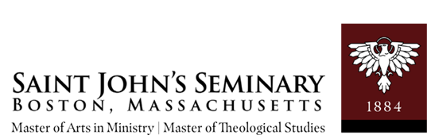

Initial application form

RECOMMENDATION INFORMATION

Applicant’s Name:
a. Parish/Institutional Recommendation:

Please select a Priest who would be able to evaluate your capacity for apostolic service as well as your potential to benefit from study in the Master of Theological Studies/Master of Arts in Ministry Degree Program of Saint John’s Seminary. This priest should be your pastor unless your Sunday Mass site is a campus ministry location or Catholic shrine.

Please provide your recommender with the Parish/Institutional Recommendation Form and addressed mailing envelope.
Name: |  |  |  |  |  |  |  |  |  | Parish/Institution:
Address:
 | (Street and Apartment/Unit#) |  |  |  |  |  |  |  |  |  | (City/Town) |  |  |  | (State) |  | (Zip Code)
Phone: ( |  |  | ) |  | - |  | Email:

__Check here to indicate that you have sent a request to your Pastor for permission to submit the original parish recommendation for PFT Scholarship application purposes. Request that the pastor email Dr. Anthony Coleman, Director of the M.A.M. & M.T.S. degree programs, with permission to use the parish recommendation for the PFT Application.
b. Other Reference:

Please select one person who could be contacted as a reference. You may select a professor, employment supervisor, volunteer supervisor from your parish or institutional experiences, or another individual who would be able to evaluate your abilities and capacity.

Name:
Position: |  |  |  |  |  |  |  |  |  |  | Institution:
Address:
 | (Street and Apartment/Unit#) |  |  |  |  |  |  |  | (City/Town) |  |  |  |  |  |  | (State) |  | (Zip Code)
Phone: ( |  |  | ) |  | - |  | Email:

Thank you for your application.
May God bless your endeavors to be formed in the Catholic faith.
Please complete this entire application and send a signed hard copy, and recommendation, to:
M.A.M./M.T.S.
Promise for Tomorrow Scholarships
127 Lake Street
Brighton, MA 02135
Attn: anthony.coleman@sjs.edu

