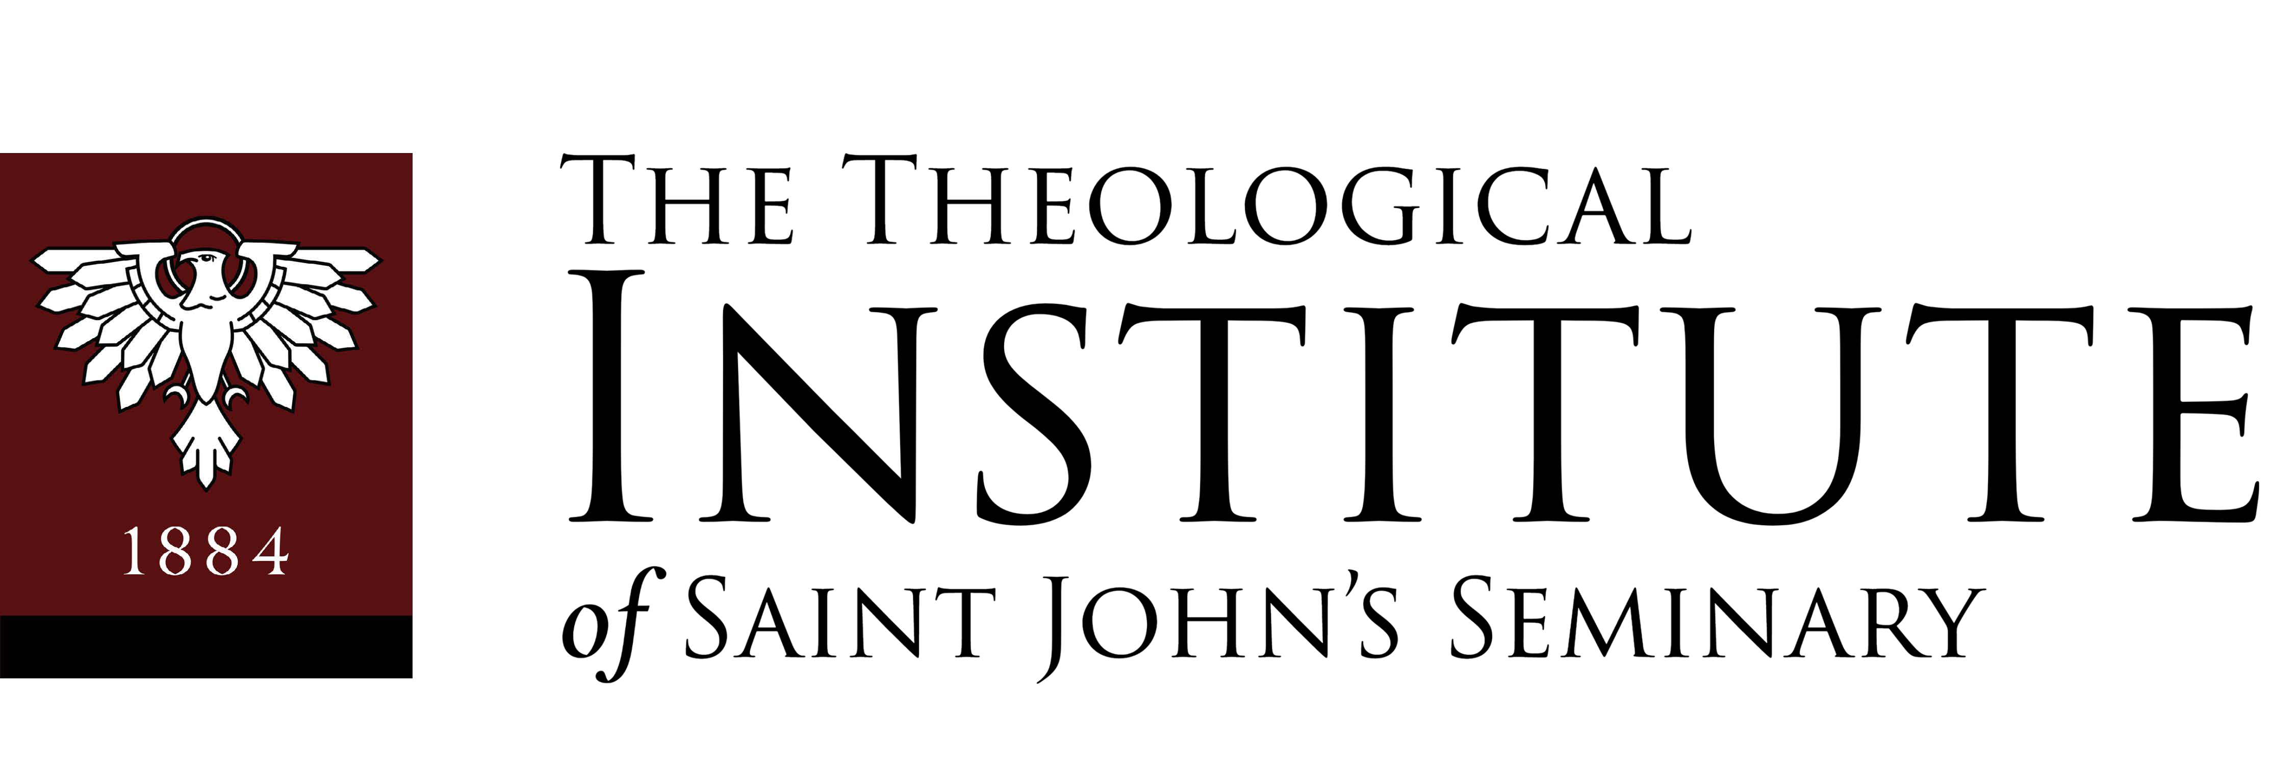

Master of Arts in Ministry Program Master of Theological Studies Program 127 Lake Street, Brighton, MA 02135

Admissions Procedure

- Begin an online application here.
- Check your email for a message from AdmissionsTI@sjs.edu containing your login credentials for our Student Information System (SIS). Please be sure to check all folders.
- Log in to our SIS to complete your application by clicking on “Application Status.”
- Upload Essay and Certificate of Sacramental Marriage (if applicable).
- Submit three recommendations (one of which must be from your pastor, a priest, or vowed religious).*
- Submit all previous undergraduate and graduate transcripts.*
- Schedule an admissions interview with the Director of the Theological Institute here.

*Note: Recommendations and transcripts should be sent directly from one’s references and institutions, respectively. They may either be emailed to AdmissionsTI@sjs.edu or mailed to:

The Theological Institute of St. John’s Seminary
127 Lake St.
Brighton, MA 02135

- An application fee of $80.00 may be mailed to the above address or submitted online through the SIS by clicking on “Financial” and then “Make a Payment.”

Tuition for the Academic Year is:

  - Tuition is $700 per academic credit; $2100 per three credit course.
  - The MAM Formation Fee is $850 per semester for four semesters.
  - The MTS Formation/Colloquium fee is $850 per semester for four semesters.
  - The field education fee is $1,000 per semester for four semesters.
  - The fee to audit a class is $420 per course.

Upon acceptance to the M.A.M. or M.T.S. degree program by the Admissions Board of Saint John’s Seminary, the applicant must confirm their acceptance.

- Financial aid and scholarships are available to qualified applicants here.

Anthony P. Coleman, Ph.D.
Director, The Theological Institute of Saint John's Seminary

